

**Oman Medical College Requirements for the Mathematics Placement Test**

1. The Advance Placement Tests in Mathematics are organized around five principal content domains:

* Numerical skills/pre-algebra
* Algebra
* College algebra
* Statistics and probability

1. These Placement tests consist of two parts:

* Part 1- Basic Mathematics
* Part-2 Pure Mathematics

1. The questions are 'multiple choice questions(MCQ’s)

* Each test will consist of 50 multiple-choice questions.
* The time allotted is 120 minutes.
* For Part I( Basic Mathematics) calculators are Not allowed
* For Part 2( Pure Mathematics) **calculators are allowed.**

1. Students have to bring their own stationeries (pen, pencil, eraser, calculators) and ID card.
2. In Basic Mathematics Placement Test, students who score 70% are eligible to take Pure Mathematics Placement exam.
3. In Pure Mathematics Placement Test, students who score 70% are exempted from doing Mathematics in the Foundation Year.

PURE MATHEMATICS: College Algebra, Statistics & Probability

The Pure Mathematics Placement Test consists of items from three curricular areas: college   
algebra/functions & graphs, descriptive statistics and probability. The Pure Mathematics   
Placement Test includes items from more than 15 content areas as follows:

1. Basic Algebra
2. Co ordinate geometry
3. Graphical Solutions
4. Definition of Function & graph
5. Domain & Range of a Function
6. Algebra of functions
7. Composition of functions
8. Inverse of a function
9. Graph by transformation
10. Linear Functions & graphs
11. Quadratic Functions and graphs
12. Polynomials Functions and graphs
13. Rational Functions and their graphs
14. Exponential Functions and their graphs
15. Applications of exponential growth/decay
16. Logarithmic Functions and their graphs
17. Exponential and Logarithmic equations.
18. Basic Descriptive Statistics
19. Basic probability Concepts
20. The domain of the following function


24. Which of the following is NOT true concerning the graph of ?

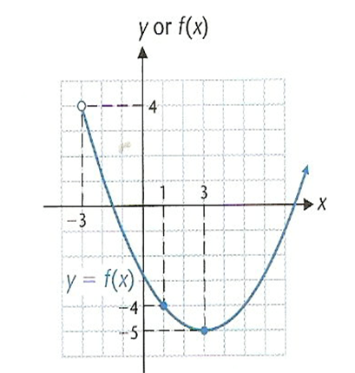

1. 
2. is increasing on [3,∞)
3. Domain of = [-3,∞)
4. Range of =[-5,∞)
5. Which of the following is true concerning the graph of the polynomial function shown below?

[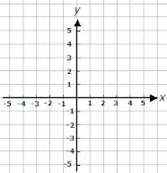](http://www.google.com/imgres?imgurl=http://www.helpingwithmath.com/printables/worksheets/geometry/grid-5_5.gif&imgrefurl=http://www.helpingwithmath.com/printables/worksheets/geometry/geo0701coords12.htm&h=241&w=233&sz=4&tbnid=CdGSy0FyJQP-aM:&tbnh=90&tbnw=87&prev=/search?q=grid+with+axis&tbm=isch&tbo=u&zoom=1&q=grid+with+axis&usg=__yDq4gBoxDckO6xhbUWO4a17Cvm4=&docid=EnemtCuQ25JFwM&sa=X&ei=s0mkUYP0J8jsrAe48IHYBQ&ved=0CD0Q9QEwBQ&dur=641)

1. The function has no real zeroes
2. The function has no turning points
3.  as and  as 
4.  as and  as 
5. Find the vertical asymptote of the rational function 
6. 
7. 
8. 
9. and 

**Answer key:** 1) D 2) C 3) D 4) B

**ALL THE BEST**