**Computer Fundamentals**

1. ___________ is used to permanently store data.
2. CU
3. ALU
4. Memory
5. Secondary Storage Devices

Ans: ______

1. Which of the following is/are not an output device?
2. Mouse
3. Scanner
4. Printer
5. both a and b

Ans: ______

1. 10 Mb is approximately equal to
2. 1000 Kb
3. 10,000,000 bytes
4. 10,000 Kb
5. Either b or c

Ans: ______

1. Floppy Disk is an example of
2. Direct Access Media
3. Sequential Access Media
4. Primary storage device

Ans: ______

1. Laser Printers are example of
2. Impact Printers
3. Non impact Printers
4. Line Printers

Ans: _________

1. A Mini Computer
2. Supports many PCs connected through a network.
3. Can function as a stand alone system.
4. Serves multi user environment.
5. All of the above.

Ans: _________

**Windows**

1. Write down the path of the highlighted folder in the given screenshot below:

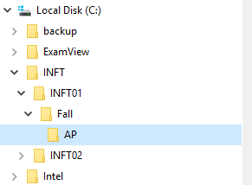

Ans:_____________________________________________

1. Make a folder by name EXAM in H:\BFINAL.
2. Make a shortcut to the folder H:\BFINAL\EXAM on desktop.
3. <Ctrl> Z is a keyboard shortcut to _______________
4. Copy
5. Move
6. Undo
7. Edit

**Ans: __________**

**INTERNET EXPLORER**

1. Goto the website [www.omc.edu.om](http://www.omc.edu.om) . Save the page in web archive format.
2. Add the above page to favorites
3. To search for information about swine flu from non profit organization websites, the most appropriate search syntax would be:
4. Swine flu insite:.org
5. Swine flu site:.org
6. Swine flu non profit organization

**Ans: _______**

**Microsoft word**

**Task 1**

A typed word document would be given and the student is expected to format it as shown in an attached document.

Any of the following features may be included in the formatted document.

* Basic font level formatting
* Paragraph level formatting – Line/Para spacing, bullets, numbering etc.
* Inserting pictures, bookmarks, header/footer, page breaks, section breaks etc
* Referencing- footnotes/endnotes
* Reviewing of document-Spell check, Grammar check
* Page layout-Orientation, margins, column layouts

**Task 2**

A simple typed tabular report is given and the student is expected to format it as shown in an attached document: Eg.

Given tabular report:

|  |  |  |  |
| --- | --- | --- | --- |
| **Course** | **Test1** | **Test2** | **Total** |
| IT | **43** | **45** |  |
| MATH | **38** | **41** |  |
| ENGLISH | **36** | **38** |  |
| STUDY SKILLS | **47** | **45** |  |

The formatted report should look like this: (total calculated using a formula)

**INDIVIDUAL TEST RESULT**

|  |  |  |  |
| --- | --- | --- | --- |
| **Course** | **Marks in** | | **Total** |
| **Test1** | **Test2** |
| IT | **43** | **45** | 88 |
| MATH | **38** | **41** | 79 |
| ENGLISH | **36** | **38** | 74 |
| STUDY SKILLS | **47** | **45** | 92 |

**POWERPOINT**

**Task 1**

**Formatting**

Given a PowerPoint presentation student is asked to perform specific task on the file like:

* Inserting/Deleting slides
* Applying /Removing slide design
* Applying/Removing slide background
* Inserting pictures
* Assigning slide layouts

**Task 2**

**Animation**



* Set the slide transition to cover Down
* Animate the given slide as follows:

1. The title eases in letter by letter
2. After a delay of 1 sec , the bullet points gets emphasized with color change one after the other

* Set the time such that the slide advances after 5 seconds.

**MICROSOFT EXCEL**

**Task1:**

A simple typed tabular report is given and the student is expected to format it as shown in an attached document: Eg.

Given tabular report:

|  |  |  |  |
| --- | --- | --- | --- |
| **Course** | **Test1** | **Test2** | **Total** |
| IT | **43** | **45** |  |
| MATH | **38** | **41** |  |
| ENGLISH | **36** | **38** |  |
| STUDY SKILLS | **47** | **45** |  |

The formatted report should look like this: (total and % calculated using excel formula, average using Excel function)

**INDIVIDUAL TEST RESULT**

|  |  |  |  |  |
| --- | --- | --- | --- | --- |
| **Course** | **Marks in** | | **Total** | **%** |
| **Test1(100)** | **Test2(100)** |
| IT | **78** | **80** | 158 | 79 |
| MATH | **80** | **94** | 174 | 87 |
| ENGLISH | **85** | **69** | 154 | 77 |
| STUDY SKILLS | **60** | **75** | 135 | 67.5 |
| **Average class performace of students** | | | | 77.625 |

**Task2 :**

**Plotting the given data into an excel chart**

* The chart must have:
  + X, Y Axis labels
  + Chart title
  + Data labels
* Student must also know to scale the X, Y axis

**Example:** Make a suitable graph in excel for the data given in the table below:

|  |  |  |  |  |  |
| --- | --- | --- | --- | --- | --- |
| City | Temp |  |  | **x** | **y=2x+1** |
| Muscat | 38 |  |  | 2 | 5 |
| Seeb | 35 |  |  | 3 | 7 |
| Salalah | 32 |  |  | 4 | 9 |
| Nizwa | 35 |  |  | 5 | 11 |
|  |  |  |  | 6 | 13 |
| **Table A** | |  |  | **Table B** | |

**MICROSOFT ACCESS**

(Student can collect sample database for practice. They are advised to get familiar with the database before attempting this module.)

* The database can be copied from college network \\dataserver\Class-2013\Samplefiles\Clinic 2011 or **from college website**.
* Refer to page 7 of the document for a brief introduction to Cinic 2011 database.

**Task**

* Students are asked to create queries based on 5 listed tables.

**E.gs**

* + List all female, Omani patients.
  + List all patients above 30 years of age.
  + List all patients who have visited the clinic in the year of 2002.
  + List patients whose names start with a.
  + List patients with hereditary history of diabetes.
  + List all patients who have an appointment with Dr. Abdullah.

**INTRODUCTION TO CLINIC -2011 (ACCESS DATABASE)**

CLINIC-2011 is a clinic database which has five tables

* + **PATIENTMASTER**-information about patients
  + **DEPT**-list of dept ids and dept names
  + **DOCTORMASTER-**information about doctors
  + **CASEFILE**-information about each patient’s visit to clinic on any given date
  + **APPOINTMENT-**register of appointments

**The relationships and primary key of each table is represented below :**

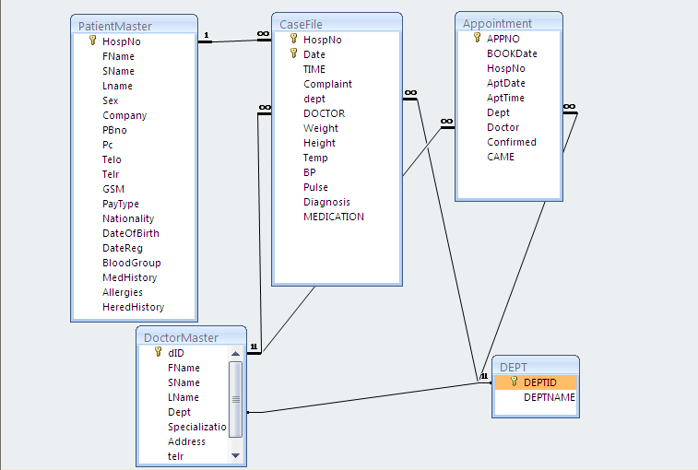

The table PATIENMASTER has **four lookup** fields:

* 1. **SEX** (M, F)
  2. **BLOODGROUP** (A, B, AB, O)
  3. **NATIONALITY (**list of countries)
  4. **PAYTYPE** (Type of patients-OP, OSP, NOP, NOSP)
     + **OP**-Omani Paying , **OSP**-Omani Sponsored
     + **NOP**-NonOmani Paying , **NOSP**-NOnOmani Sponsored

Table CASEFILE and APPOINTMENT has 2 lookup fields

* **DEPT**-gets its values from deptid of **DEPT** table
* **DOCTOR**-gets its values from did of **DOCTORMASTER**